**Prioritization of Snake River Instream PIT Tag Detection Systems for Operations & Maintenance**

Version: June 6, 2023

**BACKGROUND**

Numerous Instream PIT tag Detection Systems (IPTDS) have been installed throughout the Snake, upper Columbia, and John Day river basins to support habitat action effectiveness and status and trends monitoring initiatives developed under the Integrated Status and Effectiveness Monitoring Project (ISEMP; BPA project number 2013-007-00). However, when ISEMP was largely defunded in 2017, comanagers identified a subset of IPTDS for which continued operation was of high priority, including in the Snake River basin. The Integrated IPTDS Operations and Maintenance (O&M) project (BPA project number 2018-002-00) was created to assume O&M responsibilities for a subset of IPTDS with continued management utility.

***Objectives***

Our objective is to provide recommendations on the continued funding of O&M for IPTDS throughout the Snake River basin, to be continued under Biomark, Inc.’s project 2018-002-00 with the Bonneville Power Administration (BPA). Here, the primary goal for prioritization and selection of IPTDS is to obtain status and trends information for spring/summer-run (sp/sum) Chinook salmon and summer-run steelhead populations in the basin, including high-precision monitoring in at least one population per major population group (MPG) following the recommendations of Anadromous Salmonid Monitoring Strategy (ASMS; CBCAMW 2010). We recognize the importance that all individual IPTDS have and their ability to answer specific fish monitoring and research questions. However, our purpose is to prioritize the IPTDS sites required to obtain population abundance and life history high-level indicators (HLI; PNAMP 2009) efficiently and reliably, and to recommend them for continued or improved O&M through BPA project 2018-002-00. Ultimately, our aim is to provide a transparent framework to identify the following recommendations and/or outcomes for IPTDS: 1) removal, 2) continued funding of O&M, 3) upgrades, and/or 4) new IPTDS to address gaps or to increase cost-savings.

**GENERAL APPROACH**

Four general parameters form the key to evaluating a population’s viability status: abundance, productivity, spatial structure, and diversity (McElhany et al. 2000). The ASMS recommends the following general guidelines, among others, to assess these Viable Salmonid Population (VSP) criteria (CBCAMW 2010):

***Abundance***

* Annual adult status and trend data should be collected at high intensity monitoring (precision) for *at least* one population per life history type (spring versus summer run) per MPG. This adult monitoring should be invested in populations with high intensity juvenile and smolt abundance monitoring.
* Annual adult status and trend data should be collected at lower intensity monitoring for every population within an MPG.
* Adult monitoring should report abundance and precision (confidence intervals, CI’s) on a yearly basis in a manner that will allow abundance (and uncertainty levels) to be aggregated at larger spatial scales (e.g., MPG or ESU/DPS).
* …

***Productivity***

* Annual estimates of adult:adult productivity and CI’s for each population.
* Annual estimates of juvenile and smolt migrants and CI’s for at least one population per MPG. Juvenile and smolt monitoring should be done in populations with high intensity adult monitoring to calculate smolts per female (or smolts per spawner).
* …

***Diversity***

* Periodic sampling of populations for genetic diversity. Sample wild populations on a rotating five-year basis to maintain genetic baselines for genetic stock identification and to evaluate genetic population structure and diversity.
* Periodic monitoring of population phenotypic diversity (e.g., juvenile outmigration timing, adult run timing, spawn timing, age distribution, age at maturity, fecundity, sex ratio, size and weight)

IPTDS throughout the Snake River basin can be used to monitor adult abundance and productivity directly, as well as spatial structure and diversity, indirectly (supported by genetic and age data collected at Lower Granite Dam). As such, we considered these ASMS guidelines within the following prioritization framework.

**PRIORITIZATION FRAMEWORK**

1. First, we evaluate existing status and trends monitoring activities within each Snake River sp/sum Chinook salmon evolutionary significant unit (ESU) and steelhead distinct population segment (DPS) to determine areas with current insufficient monitoring (i.e., data gaps), or with low-precision or high-precision monitoring (see blue boxes in Figure 1). Descriptions of each are as follows:
   1. **Data Gap:** Population lacks low-precision or high-precision monitoring activities to calculate HLIs.
   2. **Low-precision Monitoring:** Population includes monitoring activities that lack information necessary to calculate HLI precision, the 5-year average coefficient of variation (CV) is > 15%, or the monitoring occurs at a spatial/temporal scale that excludes some fish returning to major spawning areas within the population. Examples of low-precision monitoring include spawning ground surveys, and picket weirs or IPTDS operated upstream of some major spawning areas.
   3. **High-precision Monitoring:** Population includes monitoring activities that provide the necessary information to calculate HLI precision, maintain a 5-year average CV of ≤ 15%, and occur at a spatial/temporal scale that includes all fish returning to major spawning areas within the population. Fish returning to minor spawning areas may be excluded. Examples of high-precision adult monitoring include picket weirs and IPTDS operated downstream of all spawning areas.
2. Next, depending on the current monitoring activities within each population (none, low-precision, or high-precision), additional questions were considered to determine an “outcome” (Figure 1). Questions considered whether other populations within the same MPG were monitored using high-precision monitoring, whether IPTDS was the sole monitoring activity within the population, whether low-precision monitoring was an option, and/or whether redundancy in monitoring was desired or necessary. Each set of questions and answers leads to an “outcome” (Figure 1).
   1. **Data Gap:** The ASMS suggests that low-intensity monitoring should be conducted for every population within an MPG/DPS. Thus, populations identified as a “data gap” should be considered as a candidate for IPTDS monitoring and/or other low-precision monitoring methods.
   2. **Low-precision Monitoring:** For populations with current low-precision monitoring, we consider two questions:
      1. Does any other population within the same MPG/DPS receive high-precision monitoring?
      2. Is the population only monitored using IPTDS?
   3. **High-precision Monitoring:** For populations with current high-precision monitoring, we consider up to five questions:
      1. Is the population currently monitored using IPTDS?
      2. Does any other population within the same MPG/DPS receive high-precision monitoring?
      3. Is IPTDS monitoring the only high-precision monitoring method used in the population?
      4. Is another low-precision monitoring method feasible within the populations?
      5. Is redundancy of two high-precision methods necessary e.g., for method validation, fish-handling, etc.?

Depending on the “Yes/No” answers to each of these questions, there are four possible “outcomes” illustrated and described in Figure 1 and Table 1, respectively.

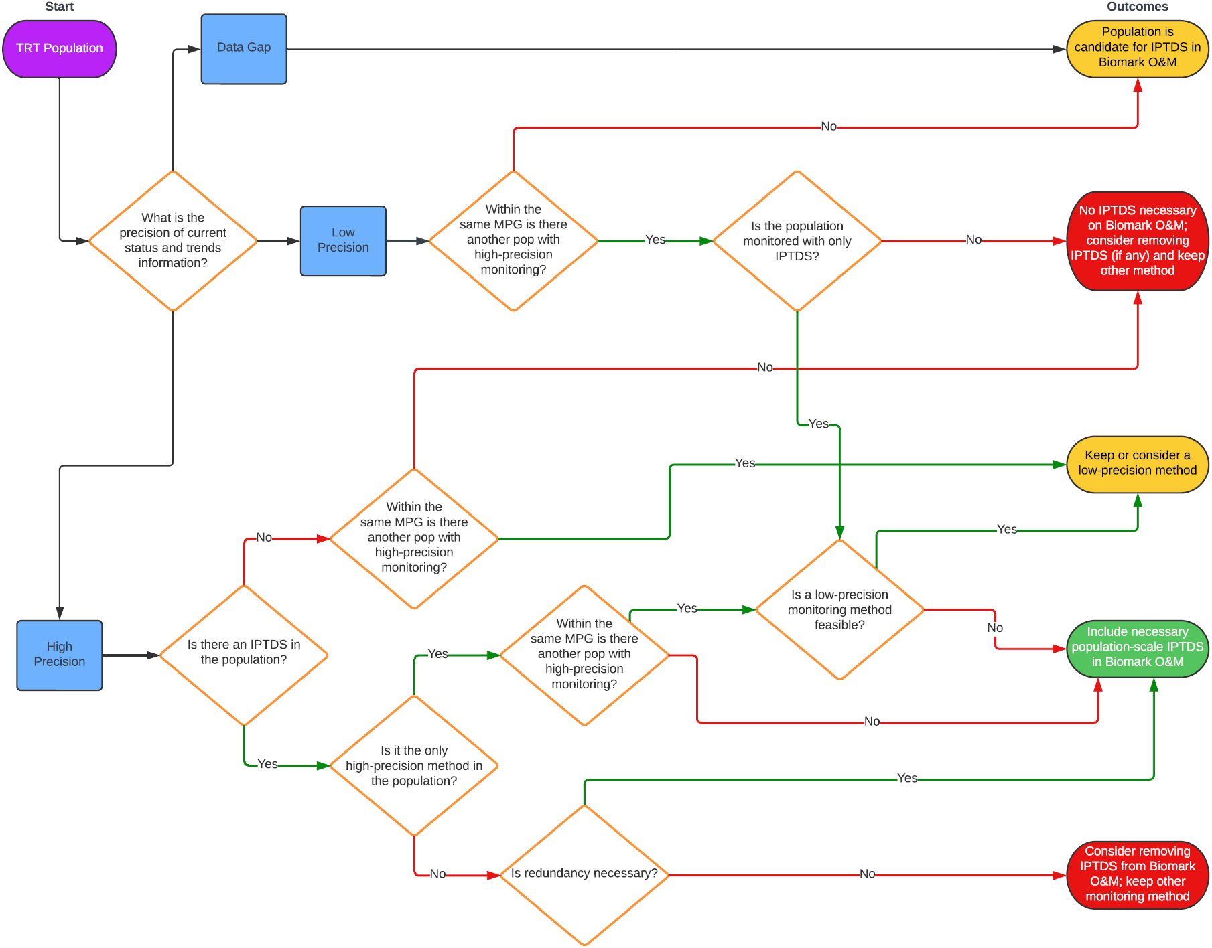

**Figure 1**. Flowchart used to determine monitoring needs for each Snake River sp/sum Chinook salmon and steelhead population, and whether IPTDS in each population should be considered for inclusion in BPA project 2018-002-00. Outcome colors are as follows: Red = candidate for removal from project 2018-002-00; yellow = further considerations needed; green = IPTDS should be operated under project 2018-002-00.

**Table 1**. Potential population-level outcomes resulting from the initial step of the prioritization framework. Red = candidate for removal from project 2018-002-00; yellow = further considerations needed; green = IPTDS should be operated under project 2018-002-00.

|  |  |
| --- | --- |
| **Outcome** | **Description** |
| **Consider removing IPTDS O&M from project 2018-002-00, but keep other monitoring method** | Outcome is for populations the either a) occur within a MPG/DPS in which another population is monitored using a high-precision method AND is monitored using another low-precision method, or b) is monitored using two redundant, high-precision methods including IPTDS and redundancy is not necessary. |
| **Population is a candidate for IPTDS-based monitoring with O&M under project 2018-002-00** | Outcome is for populations with currently no monitoring (i.e., data gaps) or for a population within an MPG/DPS that includes no population with high-precision monitoring. |
| **Consider an alternative low-precision monitoring method** | Outcome is for populations that currently experience high-precision IPTDS monitoring but occur within an MPG/DPS in which two or more populations are monitored using high-precision methods. |
| **The population should continue to be monitored using IPTDS with O&M under project 2018-002-00** | Four paths in Figure 1 lead to this outcome. In general, this outcome is for populations in which current IPTDS are necessary for either low-precision or high-precision HLI monitoring. |

1. Finally, for each population with the outcome “*Include necessary… IPTDS in Biomark O&M*” (Figure 1), we further considered which IPTDS sites within the population are necessary for status and trends monitoring and recommended for inclusion in project 2018-002-00 (Figure 2). Definitions and descriptions in Table 2 are provided to aid in interpretation of Figure 2.

**Table 2.** Definitions or descriptions that may be useful for interpretation of Figure 2.

|  |  |
| --- | --- |
| Term | Definition or Description |
| Nodes | A node is made up of a single, or group of, antenna(s) that form an independent PIT-tag detection location and can be ordered in reference to other nodes in the stream network. |
| Unbiased / Independent | IPTDS sites and/or nodes are independent if the probability of detecting a tag at one location is independent of detection at another site or node. For example, two nodes (e.g., arrays) within a short distance of each other (e.g., less than 10 meters) may not be independent if marked fish are not mixing with unmarked fish between the nodes. |
| Reliable | The site has operated continuously (or near continuously) through the adult migration period for each of the last five years for sp/sum Chinook salmon and steelhead. |

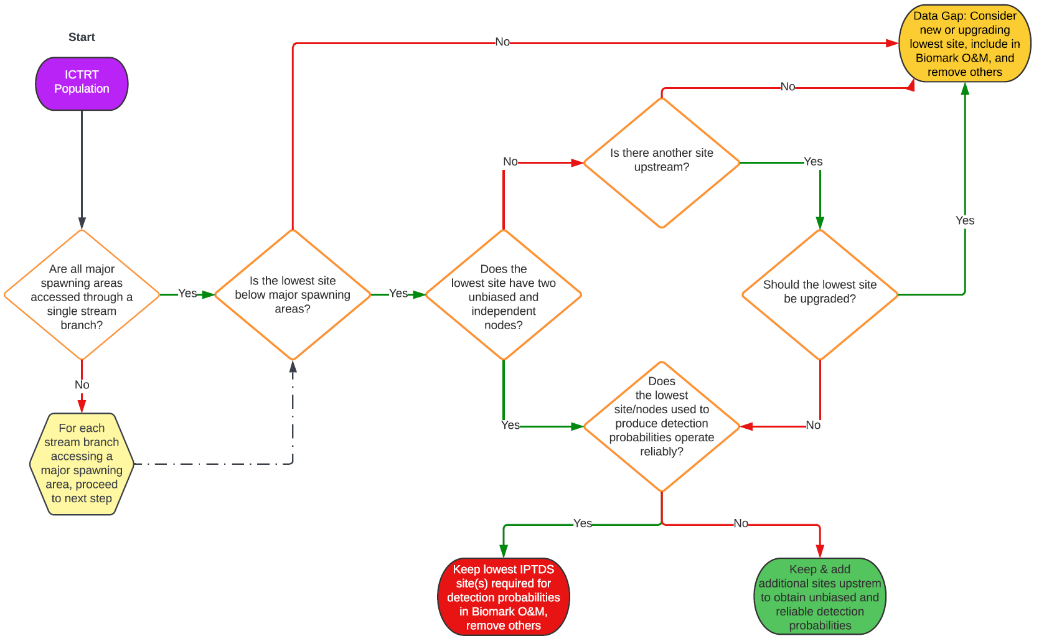

**Figure 2.** Within each population, determine which IPTDS should be considered for inclusion in Biomark, Inc.’s project, and whether any IPTDS within the population could be removed.

**RESULTS**

***Chinook salmon***

Text…

***Steelhead***

Text…

**LITERATURE CITED**

Columbia Basin Coordinated Anadromous Monitoring Workshop (CBCAMW). 2010. Anadromous Salmonid Monitoring Strategy Viable Salmonid Population Criteria and Subset of Tributary Habitat and Hatchery Effectiveness, Version 30062010. 59 pp.

McElhany, P., M.H. Ruckelshaus, M.J. Ford, T.C. Wainwright, and E.P. Bjorkstedt. 2000. Viable salmonid populations and the recovery of evolutionary significant units. U.S. Dept. Commer., NOAA Tech Memo. NMFS-NWFSC-42. 156 pp.

Pacific Northwest Aquatic Monitoring Partnership (PNAMP). 2009. High Level Indicators for Watershed Health and Salmon. May 12, 2009. 10 pp.